Design and Application of Inspection System for Mechanics Department
Arçelik Dishwasher Factory
Project Team
Kudret Arman
Alper Ayhan
A. Burcu Çolak
Ali Hüseyin Demirci
Fatih Ergen
Dilek Ölez
Industrial Engineering
Bilkent University
06800 Ankara
Industrial Advisor
N. Tanzer Tunçalp, Arçelik Dishwasher Factory,
Automatisation and Information Systems Manager
Academic Advisor
Asst. Prof. M. Murat Fadıloğlu, Bilkent University
Department of Industrial Engineering

10 December 2019

ABSTRACT
In the Arçelik Dishwasher Factory, lack of control system to calculate the performance of processes and the quality of products affects the productivity process negatively. The aim of this project is to prevent the data loss and to prepare the necessary infrastructure for the quality and improvement workers by designing and implementing a fast and user-friendly control system. The system is developed on Microsoft.NET platform using VisualBasic.NET programming language and Oracle 9.2 database. By the help of this system a sample efficiency improvement study was conducted and the efficiency is improved by 8% in terms of time and 3% in terms of productivity.
Keywords: GUI (Graphical User Interface), grid ergonomics, quality and performance improvement, process analysis.

Contents
Contents 2
1 Introduction 2
2 R Markdown 2
2.1 Including Plots 2
2.2 Further Reading 3
3 Report Format 3
3.1 Margins 4
3.2 Headings 4
3.3 Subheading 4
3.4 Bulleting and Indexing 4

Introduction
Section 2 illustrates how to create tables, figures, refer to them, and cite others’ work. Section 3 describes the report format if you are not using R Markdown.

R Markdown
This is an R Markdown document. Markdown is a simple formatting syntax for authoring HTML, PDF, and MS Word documents. For more details on using R Markdown, see http://rmarkdown.rstudio.com.
Use RStudio to create R Markdown reports. In RStudio, when you click the Knit button (or press Ctrl-Shift-K) a document will be generated that includes both content as well as the output of any embedded R code chunks within the document. You can embed an R code chunk like this:
## cat(doc.type) summary(cars)
## speed dist
## Min. : 4.0 Min. : 2.00
## 1st Qu.:12.0 1st Qu.: 26.00
## Median :15.0 Median : 36.00
## Mean :15.4 Mean : 42.98
## 3rd Qu.:19.0 3rd Qu.: 56.00
## Max. :25.0 Max. :120.00

Including Plots
You can also embed plots as in Figure 1, for example:

plot(pressure)
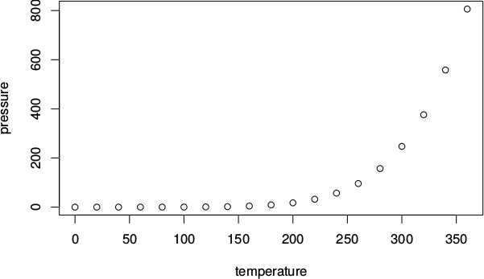
Figure 1: Pressure vs. temperature
Figure 1: Pressure vs. temperature
Note that the echo = TRUE parameter was added to the code chunk to print the R code that generated the plot. In general, you will not want the code appear and thus set echo = FALSE. You can set it FALSE globally in the first chunk of your document. Table 1 displays the first six lines of data plotted in Figure 1.

Table 1: The first six records of pressure versus temperature
temperature | pressure
0 | 2e-04
20 | 0.0012
40 | 0.006
60 | 0.03
80 | 0.09
100 | 0.27

Further Reading
Read Xie et al. (2018) for more on R Markdown. Wickham and Grolemund (2017) will also be useful.

Report Format
The text must be written in ‘Times New Roman’ font using 12 pt and single spaced and justified. The first paragraphs in each section/subsection/… should not be indented. All others should be indented 1 cm. There must be no line blanking between paragraphs.

Margins
Top and bottom margins must be 3 cm, right and left margins must be 3.75 cm width. All headings, tables, figures, texts and appendices must be between the spacing limits that are determined by margins, there must no text outside of these limits. ( Please ensure that all tables and figures that you used in the text and appendix are between the margins.)

Headings
Headings must be written in 16 pt, bold. The first character of each word must be a capital letter. In the headings of reports written in Turkish, conjunctions like ‘ve’, ‘ile’ must be written in lowercase. In the headings of reports written in English, auxiliary words like ‘the’, ‘on’, ‘for’ must be written in lowercase. All headings must be enumerated.

Subheading
Subheadings must be written in 12 pt, following the heading number. The first character of a subheading must be uppercase, and other characters must be lowercase. There must be no dot after the last character of any headings or subheadings.
Headings should not be chained without any remarks in between. When a new section or sub section or sub sub section is created, greet the reader with the purpose of section and give a brief review of its content and the contents of its sub sections.

Sub sub heading
The same subheading rules apply. A fourth subheading should not be used like 3.2.2.1. If there is a heading, definition etc. that you do not want to enumerate, it must be written in italic and there must be “:” (double dot) after that. Example:
MDB: Main distribution base.
MDB network: the network that is created by main distribution bases and their connection.

Bulleting and Indexing

Bulleting
Bulleting should be left-aligned and only the round shape should be used. Manuscripts should start from 1 cm inside. Example:
The objectives can be listed in more detail as follows:
- Measuring the performance of molds, operators and press machines where products are produced, in line with the expectations of the enterprise.
  - Measuring the molds in which the products are produced, in line with the expectations of the enterprise.
  - Measuring the molds in which the products are produced, in line with the expectations of the enterprise.
- A system design that will allow the measurement of the quality of all kinds of raw materials, semi-finished products and especially the materials from the supplier companies that are processed in press machines.
- All performance analysis reports are designed to be available to senior management in an intranet environment and include multiple user levels (senior management, system management and operators), allowing all units to access the data in the fastest way.

Indexing
Numbering should be written in the same format as the bulleting, an example is as follows. Example:
The objectives can be listed in more detail as follows:
- Measuring the performance of molds, operators and press machines where products are produced, in line with the expectations of the enterprise.
  - Measuring the molds in which the products are produced, in line with the expectations of the enterprise.
  - Measuring the molds in which the products are produced, in line with the expectations of the enterprise.
- A system design that will allow the measurement of the quality of all kinds of raw materials, semi-finished products and especially the materials from the supplier companies that are processed in press machines.
- All performance analysis reports are designed to be available to senior management in an intranet environment and include multiple user levels (senior management, system management and operators), allowing all units to access the data in the fastest way.
- Establishing a database that will prepare the infrastructure for the total quality management activities that are being carried out in the enterprise, and providing the opportunity to obtain a healthy data for these studies.

Figures and Tables

Tables
Tables should be within the specified writing range and should not protrude in any way. The title of the table should be numbered; see Table 2 as an example, centered on the table and there should be one empty line before and after the table.
Table 2: Daily average intermediate stock levels in mechanical production
Material Name | Material Level
Chasis | 5,000
Side Wall | 15,000-17,000
Door | 15,000-17,000
TOTAL | 35,000-39,000

Figures
Figures should be within the specified writing range and should not protrude in any way. All graphics and photographs except tables should be presented as figures. Figures should be included in the text and should be legible. The title of the figure should be numbered, centered below the figure; see Figure 2 as an example, and an empty line should be left before and after the figure.
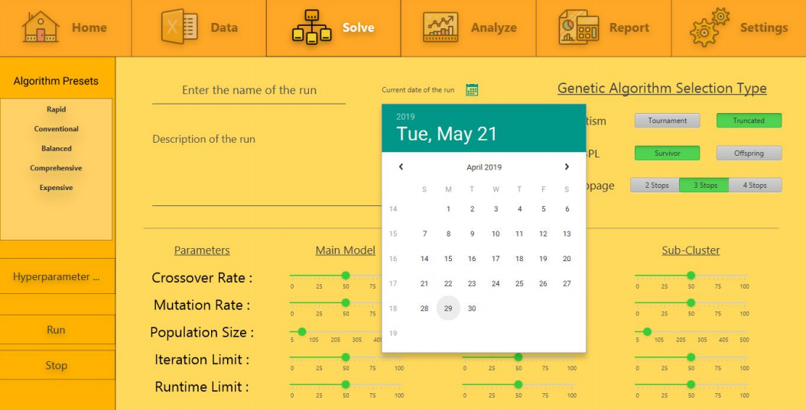
Figure 2: User interface example
Figure 2: User interface example

Referencing the tables and figures
When referring to the figures and tables, the name of the figure and the table can be written in parentheses (Table 2), or in the sentence “as shown in Figure 1”. All the other uses (see table-2, figure: 1) are not correct.

Numbers and punctuation marks
In Turkish spelling, “,” (comma) is used as the fractional number separator and “.” (Dot) is used as the separator for thousands of digits (three zeros). Examples: 2.23; 12356.2.
In English spelling, “.” (Dot) is used as a fractional number separator and ”,” (comma) is used as a separator for thousands of digits (three zeros). Examples: 2.23; 12,356.2. Thousands of digits are used for numbers with five or more digits. Four-digit numbers do not use thousands separators. Example: 4234 (four thousand two hundred and thirty-four).
In Turkish writing, the percent sign (%) is before the number (Example: %15). In the English spelling, the percentage (%) sign is located after the number (Example: 15%). Numbers from one to nine are written in text and numbers greater than or equal to 10 are written as numbers.
The letters and symbols in mathematical expressions are written in italic characters, whereas the numbers and punctuation marks (such as parenthesis, colon, and equality) are written in normal (non-italic) characters. In R Markdown, one can write math with LaTeX commands (Oetiker et al. 2015). Inline and displayed math example (Wikipedia 2019b):
The standard newswendor profit function is , where  is the random demand with cdf , each unit is sold for price  and purchased for price , the number of units stocked (decision variable) is . The stocking quantity of the newsvendor that maximizes expected profit is given by
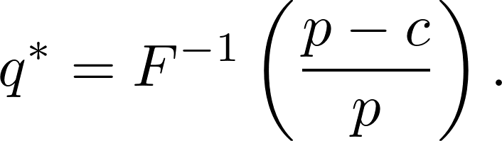
Fertilizer linear programming example (Wikipedia 2019a):

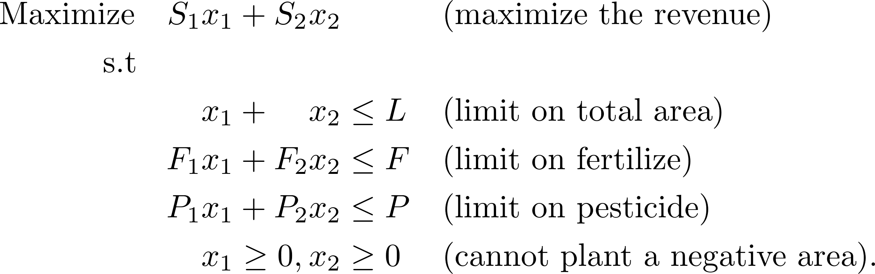

Common mistakes
The English word ‘data’ is plural, so there is no ‘datas’ in English, ‘veriler’ is the corresponding Turkish word. In Turkish, ‘veri’ or ‘veriler’ words should be preferred.
The word “heuristic” in English can be used as both a noun and an adjective. The Turkish equivalent of the word, ‘sezgisel’ is an adjective. Therefore, whether or not the word ‘heuristic’ is used as a noun or adjective in an English text or speech, for the Turkish equivalents, ‘sezgisel algoritma’ or ‘sezgisel yöntem’ should be used.
“Agenda” or “Outline” titles may be used in English to indicate the content of the presentation at the beginning of a presentation. Some of the Turkish words that correspond to these words may be ‘gündem’, ‘acenda’ or ‘içerik’. The use of the word ‘Ajanda’ in this sense is incorrect.
GAMS, CPLEX, AMPL, EXPRESS, EXCEL have different functions for modeling and solution of developed mathematical models. These functions must be correctly expressed in the text. Software such as GAMS and AMPL are interface software where mathematical models can be algebraically expressed with their own syntax and can communicate with a solver. The mathematical models encoded with these software are optimized by a decoder program such as CPLEX and EXPRESS.
Similarly, mathematical models can be expressed in Excel worksheets with Excel software. These models can be optimized with Solver, an Excel add-on. Therefore, in Turkish (English) texts, statements such as
“Matematiksel modelimizi GAMS’de çözdürdük” (“We solved our mathematical model by GAMS”),
“Bir GAMS modeli geliştirdik” (“We developed a GAMS model”),
“Problemimizi GAMS’de modelledik” (“We formulated our problem in GAMS”)
are false. Correct expressions in the Turkish (English) text as follows:
“Problemimiz için bir matematiksel model geliştirdik.” (“We developed a mathematical model for our problem”),
“Matematiksel modelimizi GAMS ile kodladık ve CPLEX ile çözdürdük.” (We coded our mathematical model in GAMS and optimized with CPLEX”),
“EXPRESS programı ile modelimizi kodladık ve optimal değerleri bulduk.” (“We coded our model and optimized in EXPRESS.”),
“AMPL arayüzünü kullanarak modellediğimiz problemimizin optimal çözümünü bulabilmek için CPLEX çözücüsünü kullandık.” (“We used AMPL interface to optimize our model by CPLEX solver”).

Bibliography
Bibliography should be included at the end of the report, starting from a separate page. The title of the bibliography should not be numbered and should be written in bold, 12-point Times New Roman, and capital letters.
All articles, books, internet pages etc. citations should be included in the text and listed in the bibliography. Studies not referred to in the text should not be included in the bibliography.
All references listed in the bibliography should be given after a line space followed by the title and aligned to the left hand side only. References should be given in the second line starting from 1 cm inside (paragraph settings: 1 cm hanging).
In the bibliography, the authors should be mentioned primarily using their last name, followed by the first letters of their names. The bibliography should be prepared alphabetically by the last name of the authors and chronologically for each author.
Turkish texts should not contain any English words except the title of the source in the bibliography. (E.g. and, volume (vol.), number (no.), page (p.) do not use words such as.)
One way to avoid the hassle of formatting bibliographic entries is this: 1) find BibTeX entries for books from Google Books, BibSonomy and for articles from journal web sites (try googling the article title and bibtex as well), 2) save them in a .bib file, 3) give the .bib file name across bibliography field in the R Markdown file (inspect report.bib file), and cite the work with its bibtex identifier.
Include an in-text citation when you refer to, summarize, paraphrase, or quote from another source. For every in-text citation in your report, there must be a corresponding entry in your bibliography.
APA in-text citation style uses the author’s last name and the year of publication, for example: Porteus (2002) . This is the case if the source is single authored. If it is two authors, write two authors’ last names using “and”, and the year of publication again, for example: Clark and Scarf (2004). If it is more than two authors, write as, for example: İçöz et al. (2006).
In Turkish texts, use again the author’s last name and the year of publication, for example: Porteus (2002). This is the case if the source is single authored. If it is two authors, write two authors’ last names using “and”, and the year of publication again, for example: Cooper ve Kameri (2004). If it is more than two authors, write as, for example: Dix vd. (2002).
When referring to a source in a sentence, the structure of the sentence must be established as if it does not refer to the source itself but to its authors. A correct example in Turkish text:
“Özellikle, Ambler (2000) ve Hoc (2000) form ergonomileri üzerine yapılan çalışmaların gerekliliğini göstermiştir”.
An incorrect example in Turkish text:
“Form ergonomileri üzerine yapılan çalışmaların gerekliliği Ambler (2000) ve Hoc (2000)’da gösterilmiştir”.
A correct example in English text:
“Clark and Scarf (2004) characterize optimal ordering policies for an uncapacitated serial inventory system”.
An incorrect example in English text:
“Optimal ordering policies for an uncapacitated serial inventory system is characterized in Clark and Scarf (2004)”.
For multiple works of an author that have appeared in the same year, the distinction is made with letters after the year, respectively. Example: (Wikipedia contributors 2019a, 2019b; Fisher 1981; Wickham and Grolemund 2017). A similar path is followed for internet addresses. Example: the internet addresses given in the bibliography below should be referred to as Beckers and Siermann (2005) and Turkish Statistical Institute (2006).
For direct quotations, include the page number as well, for example: Clark and Scarf (2004 pg. 14). For sources such as websites and e-books that have no page numbers, use a paragraph number. More information on citing sources without pagination is given on the APA Style web page. Example paragraph with in-text citation:
A few researchers in the linguistics field have developed training programs designed to improve native speakers’ ability to understand accented speech (Derwing, Rossiter, and Munro 2002; Thomas 2004). Their training techniques are based on the research described above indicating that comprehension improves with exposure to non-native speech. Derwing, Rossiter, and Munro (2002) conducted their training with students preparing to be social workers, but note that other professionals who work with non-native speakers could benefit from a similar program. See the examples in the bibliography section at the end.

Appendices
The Appendix should start on a separate page. The title should be written in bold and capital letters.
All appendices should be labeled consecutively and each one must have a title. If an appendix has subheadings, they should be numbered as well (e.g., Appendix A.1). Appendix can be referenced just as an ordinary section; for example, Figure 3 in Appendix A, consult Appendix A.1, A.2. For example, “organization chart of the company can be seen in Appendix A.2.”
Appendices should be included in the same file as the continuation of the report. Appendices should not have a landscape layout. (However, pictures and tables can be positioned horizontally as shown in Appendix B.) The appendices must not exceed the specified document margins.
      - Raw Material Flow Chart
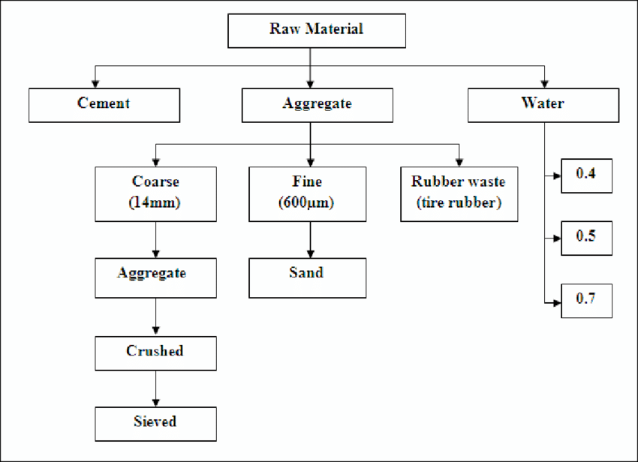
Figure 3: Raw Material Flow Chart shows that …

        - Routing Plan Obtained From the Heuristic Method
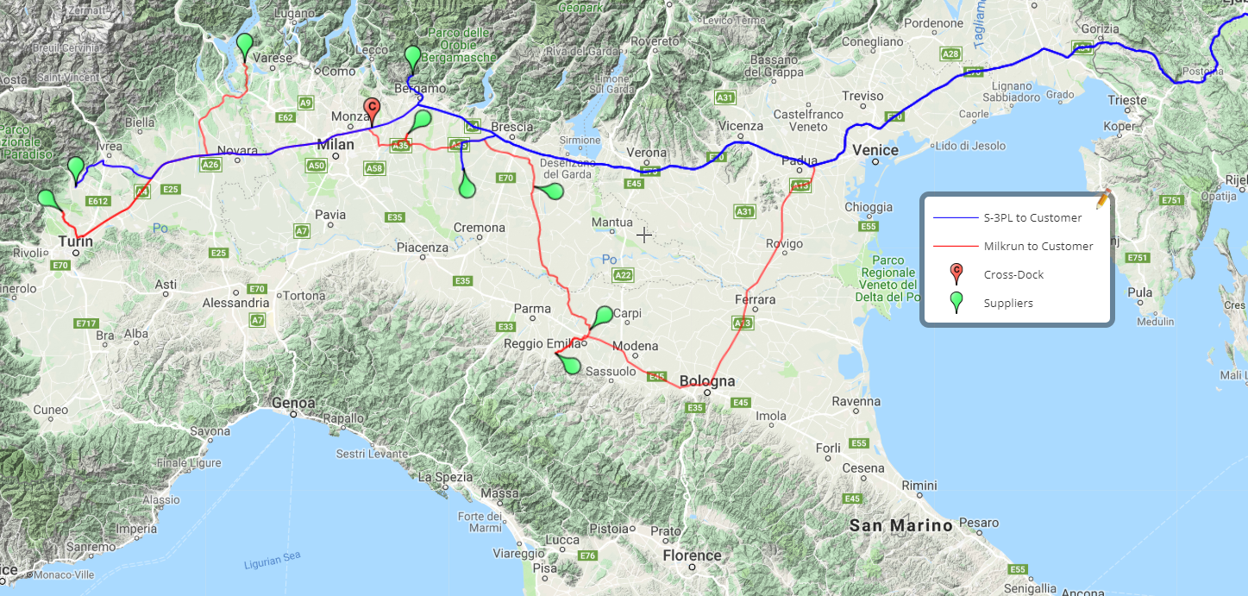
Figure 4: Routing Plan was obtained with the heuristic method developed in Section 3

        - Sample Report in the User Interface
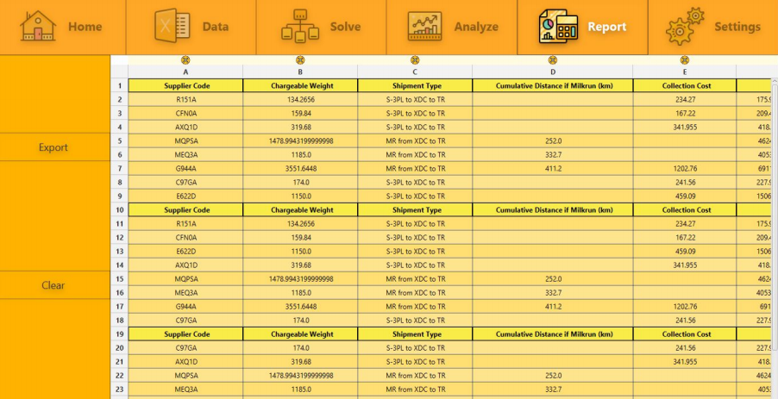
Figure 5: This report shows that …
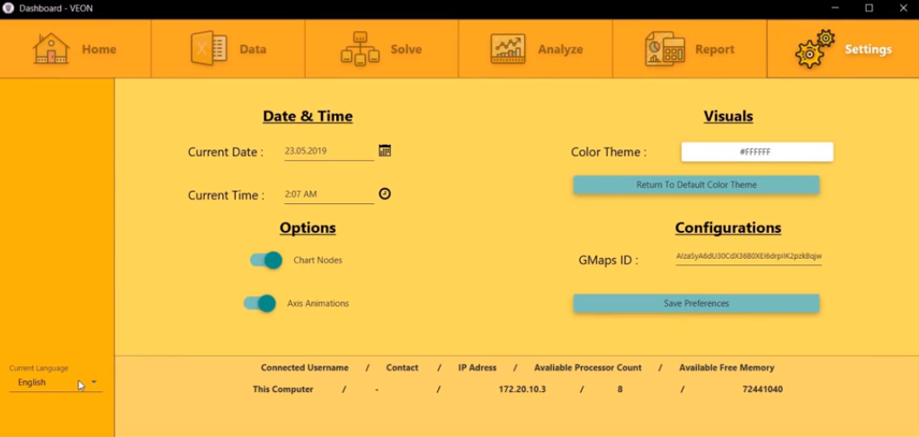
Figure 6: Connecting with other computers
      - Locations of the Distribution Centers

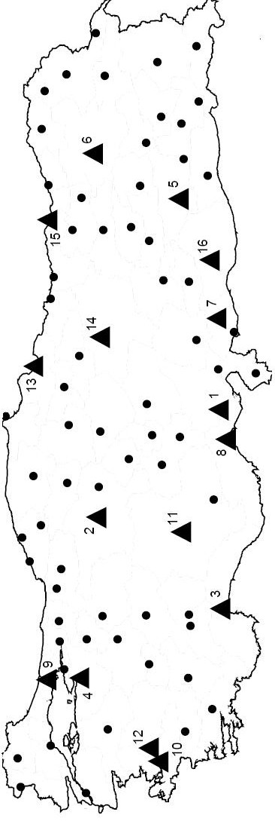
Figure 7: Solid triangles show the hubs whereas solid circles are the demand points

BIBLIOGRAPHY
Ambler, S. W. 2000. User Interface Design: Tips and Techniques. Cambridge University Press.
Beckers, I., and C Siermann. 2005. “Over One Third of Jobholders Are Regularly Working Overtime.” Web Magazine, Statistics Netherlands, http://www.cbs.nl/en-gb/menu/themas/arbeid-inkomen-sociale-zekerheid/arbeidsmarkt/publicaties/artikelen/2005-1749-wm.htm [Online; accessed March 9, 2006].
Clark, Andrew J., and Herbert E. Scarf. 2004. “Optimal Policies for a Multi-Echelon Inventory Problem.” Management Science 50 (12-Supplement): 1782–90. http://dblp.uni-trier.de/db/journals/mansci/mansci50.html#ClarkS04.
Derwing, Tracey M., Marian J. Rossiter, and Murray J. Munro. 2002. “Teaching Native Speakers to Listen to Foreign-Accented Speech.” Journal of Multilingual and Multicultural Development 23 (4). Routledge: 245–59. https://doi.org/10.1080/01434630208666468.
Fisher, Marshall L. 1981. “The Lagrangian Relaxation Method for Solving Integer Programming Problems.” Management Science 27 (1). http://www.jstor.org/stable/30046157.
Hoc, Jean-Michel. 2000. “From Human – Machine Interaction to Human – Machine Cooperation.” Ergonomics 43 (7). Taylor & Francis: 833–43. https://doi.org/10.1080/001401300409044.
İçöz, O.C., H. Başer, G. Bulut, and İ.K. Altınel. 2006. “Sınırlı Sığalı Yerleştirme-Paylaştırma Problemlerinin Eniyi Amaç Fonksiyon Değeri Için Bir Güven Aralığı Bulma Yöntemi.” Endüstri Mühendisliği 17 (3): 31–40.
Oetiker, Tobias, Hubert Partl, Irene Hyna, and Elisabeth Schlegl. 2015. “The Not so Short Introduction to : Or in 157 Minutes.” http://www.ctan.org/tex-archive/info/lshort/english/.
Porteus, E.L. 2002. Foundations of Stochastic Inventory Theory. Business/Marketing. Stanford University Press. https://books.google.com.tr/books?id=ogsrj7PnyHIC.
Thomas, Holly Krech. 2004. “Training Strategies for Improving Listeners’ Comprehension of Foreign-Accented Speech.” PhD thesis, University Libraries Digitized Theses: University of Colorado Boulder.
Türkiye İstatistik Kurumu. 2006. “Over One Third of Jobholders Are Regularly Working Overtime.” İş Gücü Anketi June 2006, http://www.turkstat.gov.tr [Online; accessed June 10, 2007].
Wickham, H., and G. Grolemund. 2017. R for Data Science. O’Reilly Media. https://books.google.com.tr/books?id=aZRYrgEACAAJ.
Wikipedia contributors. 2019a. “Linear Programming — Wikipedia, the Free Encyclopedia.” https://en.wikipedia.org/w/index.php?title=Linear_programming&oldid=920481845 [Online; accessed 17-October-2019].
———. 2019b. “Newsvendor Model — Wikipedia, the Free Encyclopedia.” https://en.wikipedia.org/w/index.php?title=Newsvendor_model&oldid=920859435 [Online; accessed 17-October-2019].
Xie, Y., J. Allaire, and G. Grolemund. 2018. R Markdown: The Definitive Guide. Chapman and Hall/Crc the R Series. Taylor & Francis Limited. https://books.google.com.tr/books?id=j9YyuAEACAAJ.

