Bakırköy Municipality
Earthquake Preparedness
Case Study

Bahar Yetiş Kara, Feyza Güliz Şahinyazan, Görkem Özdemir

INTRODUCTION
Turkey lies in the Mediterranean seismic zone and 60% of Turkey’s territory is located in active seismic belt. The following graph is the Earthquake Hazard Map of Turkey.
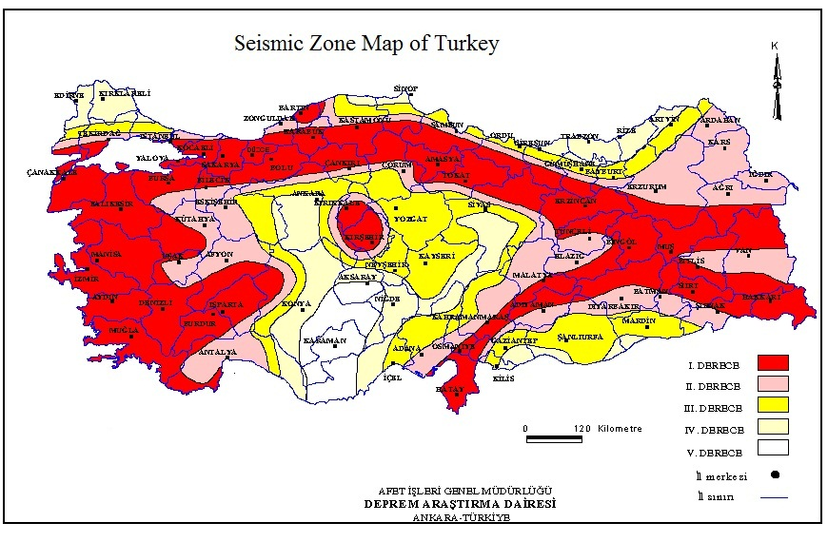Map 1: Seismic Zone Map of Turkey
Starting from 1939 Erzurum earthquake, there have been several earthquakes in Turkey and these quakes are moving towards to the west of Turkey. According to both national and international studies, in the next 20 years a severe earthquake (around 6-10 magnitude) is being expected to hit Istanbul.
Recent Earthquakes in Turkey
- 13 March 1992 – Erzincan: The magnitude was 6.8 and approximately 650 people have died whereas the number of injured people was around 3800.
- 17 August 1999 – Izmit: The magnitude was 7.4 and approximately 17480 people have died whereas the number of injured people was around 40000.
- 12 November 1999 – Düzce: The magnitude was 7.5 and approximately 763 people have died whereas the number of injured people was around 5000.
- 23 October 2011 – Van: The magnitude was 7.2 and approximately 240 people have died whereas the number of injured people was more than 1500.
- 9 November 2011 – Van: The magnitude was 5.6 and approximately 40 people have died.

These earthquakes were highly severe and resulted in death and injury of thousands of people. One of the major problems observed in these three earthquakes was the disorganized management of resources came from both international and national organizations and similarly inefficient usage of resources at present. In general, the symptoms observed in these earthquakes are listed in details below.
- Lack of standardization of services: The resources sent to the earthquake districts could not received by the earthquake sufferers because there were no officials responsible for managing resources. As a result, resources were wasted and as time passes they became out of date and/or stolen.
- Lack of Information Technology: There were no database systems that allow people to manage material flow in & out of storage areas. Since there was no material tracking system, the amount and kind of materials required by victims could not be determined.
- No Resource Classification: Lack of the list of required materials due to poor classification of resources.
- Lack of Funds Dedicated to Preparedness: The people on the disaster area lacked the awareness of a Disaster Management Center and its function therefore they could not direct the resources to the center.
- Poor Coordination Systems: Lack of simple guidelines that could help the responsible people for managing the system. (Altay, Prasad & Sounderpandian , 2006)
International Disaster Management Policy
Earthquake Response System: Consists of 4 main stages:
- Mitigation
- Preparation
- Response
- Recovery
The first two stages are considered as the Pre-Earthquake Risk Management, while the last two are considered as the Post-Earthquake Risk Management.
- Mitigation
Operations conducted in that stage occurs in a wide range of application level from dwelling unit to country.
- Revising the regulations of construction and earthquake.
- Re-defining the earthquake risk in macro and micro level, preparing earthquake maps.
- Planning and conducting necessary scientific and technical R&D projects.
- Developing and applying engineering precautions to mitigate the effects of an earthquake.
Those operations require interdisciplinary, cooperative and long-term work of various institutions.

- Preparation:
- Centralized disaster management planning
- City-based emergency response planning
- Training of authorized personnel
- Establishing regional equipment centers and stocking of critical materials.
- Organizing, improving, education and generalizing of the search and rescue teams
- Establishing, managing and improving prediction, pre-alert and alarm systems
As an example of this stage, the strength of houses should be inspected before the approval of application of a house mortgage loan.

- Response
Response stage consists of the operations starting immediately after the earthquake. Those operations should be conducted as quick as possible and in most appropriate way.
- Communication and transportation
- Identifying the needs.
- Research and rescue
- First-aid and treatment
- Evacuation
- Temporary dwelling
- Food, clothes, fuel procurement
- Security
- Environmental health and preventive medicine
- Damage detection
- Removing dangerous debris.
The operations in that stage requires perfect coordination of stakeholders since all resources of state needed to be used in quickest and most effective ways.
- Recovery
The main aim of the operations conducted in that stage is to meet the needs of effected societies like communication, transportation, water, electricity, sewerage, education, long term temporary dwelling.
Re-constructing the houses and re-activating the business can be shown as an example of operations in that stage.

Search and Rescue
Table 1 indicates the probability of survival, which dramatically decreases as the time passes. Therefore, the first three days are most crucial time for search and rescue operations so as to reduce human loss.
Time | Survival percentage
First 30 minutes | 93%
1. day | 81%
2. day | 36%
3. day | 33%
4. day | 19%
5. day | 7%
Table 1 – Time Based Survival Percentage

Past experience: August 17 1999
Izmit earthquake, which took place on August 17th, 1999, was one of the most destructive earthquakes that have ever happened in Turkey. The official attrition numbers of the first two days announced by the Ministry of Internal Affairs is as following:

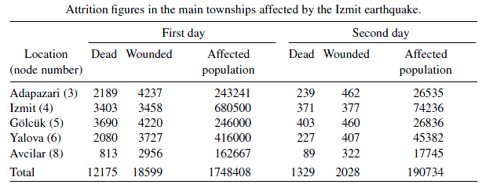
Table 2
In addition, total number of deaths was 17727, injuries 43959 and affected population was more than 2 million. Moreover, the chaos after the earthquake created serious problems in resource allocation. Although the number of supplies is huge, even adequate in some cases (Table 3), the complaints show that the allocation processes were not effective.
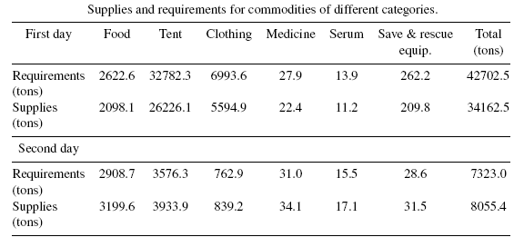
Table 3
Bakırköy Municipality Earthquake Preparedness Case Study

Due Date: May 16th, 2019

Bakırköy Municipality
Bakırköy Municipality is one of the biggest municipalities in Istanbul in terms of both surface area and population. Although the official population count of the municipality is around 222.370 (Turkish Statistical Institute, 2017), it goes up to 2 million at day time as it has an important role in Istanbul’s economy and stands in the center of other municipalities. Therefore, any serious destruction that might occur would be a considerable threat to the socio-economic development sustainability of Turkey. Moreover, a possible earthquake can cause multitudinous human loss because of high population density inside the municipality borders. Hence, Bakırköy Municipality has been involved in numerous projects to take precautions and decrease any risk concerning the situation.
Bakırköy Disaster Coordination Center (BAKOM) aims to recover the effects of disaster as much as possible by coordinating the units belong to the municipality and other related civil service groups inside the Bakırköy County before and after a disaster. After a disaster occurs, County Rescue and Aid Committee members meet at the crises center. Crises Center makes decisions and instructs BAKOM. In this structure, the role of Bakırköy Municipality is managing its own resources and providing support for other civil groups.
You, as a team, are assigned to the earthquake planning project conducted by BAKOM. The project consists of three main parts,

- In advance actions planning
- Status Detection
- Resource Assignment

Bakırköy Municipality Case

Question 1:
There are 93 districts which have to receive service. You are given the distances between these districts, the population of each district, the risk coefficient of each link that connects the districts (if the risk coefficient is high then the probability that the link is out of use is also high.) The municipality plans to open distribution centers for basic aid. Since the roads and/or the vehicles may be damaged, people may walk to those distribution centers from districts.
- Assume the municipality will open 5 distribution centers. Give a mathematical model that determines the locations of DC’s while minimizing the longest distance(R) that a person needs to travel to reach a DC. Remember that each district should be covered by at least one DC. Give your findings (results).
- Now assume the municipality decides that each district should be covered by at least two DCs within a range(R). Use the R value that you have found in part a). How do you model this situation? Give your findings (results).
- Conduct a sensitivity analysis on the number of distribution centers for part a) and give your results (corresponding R values).
- Consider part a) again. But, this time assume the municipality also wants to consider the risk of destruction of the roads.(1=remains perfectly, 0=totally demolished) So, they want each district can access the DC that they are assigned to, using a link with a risk coefficient greater than 0,7. Again minimize the longest distance(R) that a person needs to travel to reach a DC.
Question 2:
- Emergency Response Center (ERC) considers using motorcycles right after an earthquake in order to have an idea about the status of districts in Bakırköy after the earthquake within 2 hour time. According to plan, each node should be visited by a motorcycle right after the earthquake. Assume the motorcycles are located in ERC (node #1 of the data set) and they can travel 30 km/h on the average. Find the minimum number of motorcycles to be used?
- Now conduct a sensitivity analysis on part a. Decrease the total visit time from 2 hours to 1 hour with increments 0.25 hrs. Note the # of motorcycles required for each step.
- Now we want to relocate the ERC. Among the distribution centers that you open in Q1 part a, where do you move ERC. Use the number of motorcycles that you have found in part a.
- Now assume we can locate the motorcycles in more than one DC’s. (Still you will choose the motorcycle locations from Q1 part a) How many motorcycles should locate in which DC’s, in order to visit all districts in 1 hour this time?

Office Hours:

-May 3, 2019 – 12.40-13.40

-May 10, 2019 – 12.40-13.40

-May 15, 2019 – 12.40-13.40

